CSE 111 Fall 2019: Project Phase 1

GoodMail

Zhuohong Chen, Joyce Truong

**Synopsis**

Use case: The main use cases would be

* The sender composing an email, which includes its subject name, the recipient's name, the date, the message, and an optional attachment, that is received by the recipient.
* The sender or recipient adding a selected email to a specified folder of emails.
* The sender or recipient adding a note of their own message.
* The emails are automatically saved to a certain cat

**UML Use Case Diagram**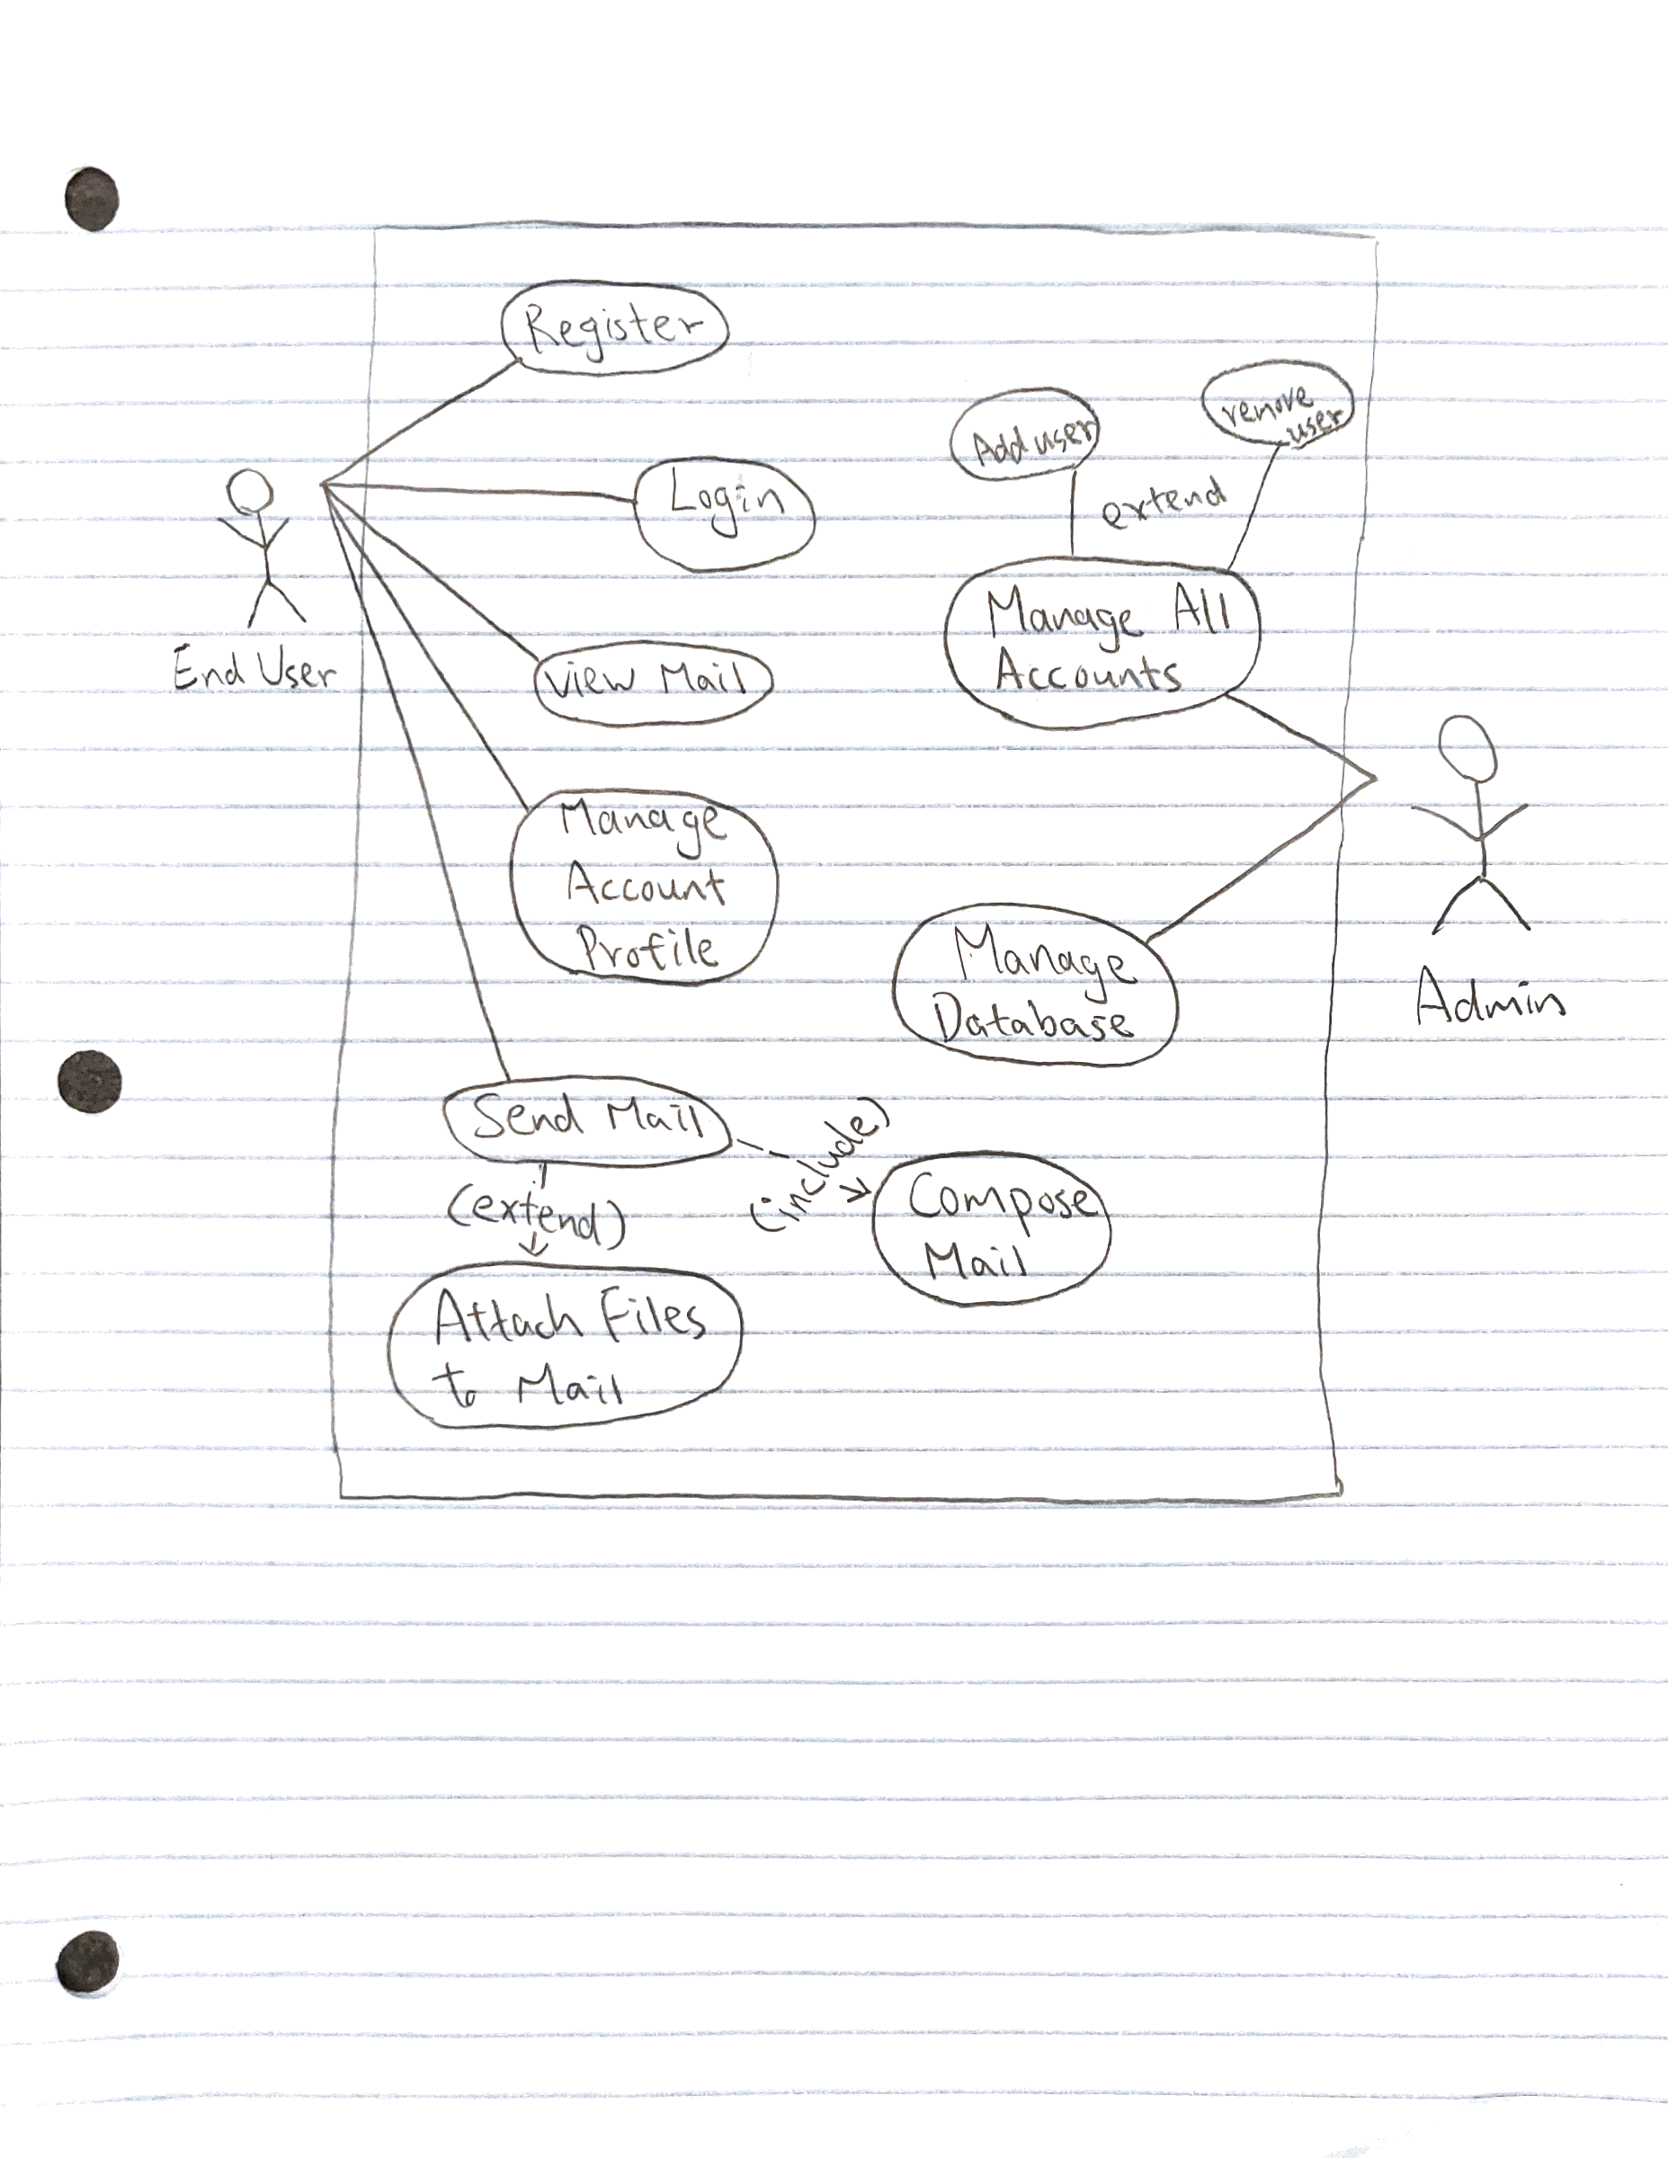

**ER Diagram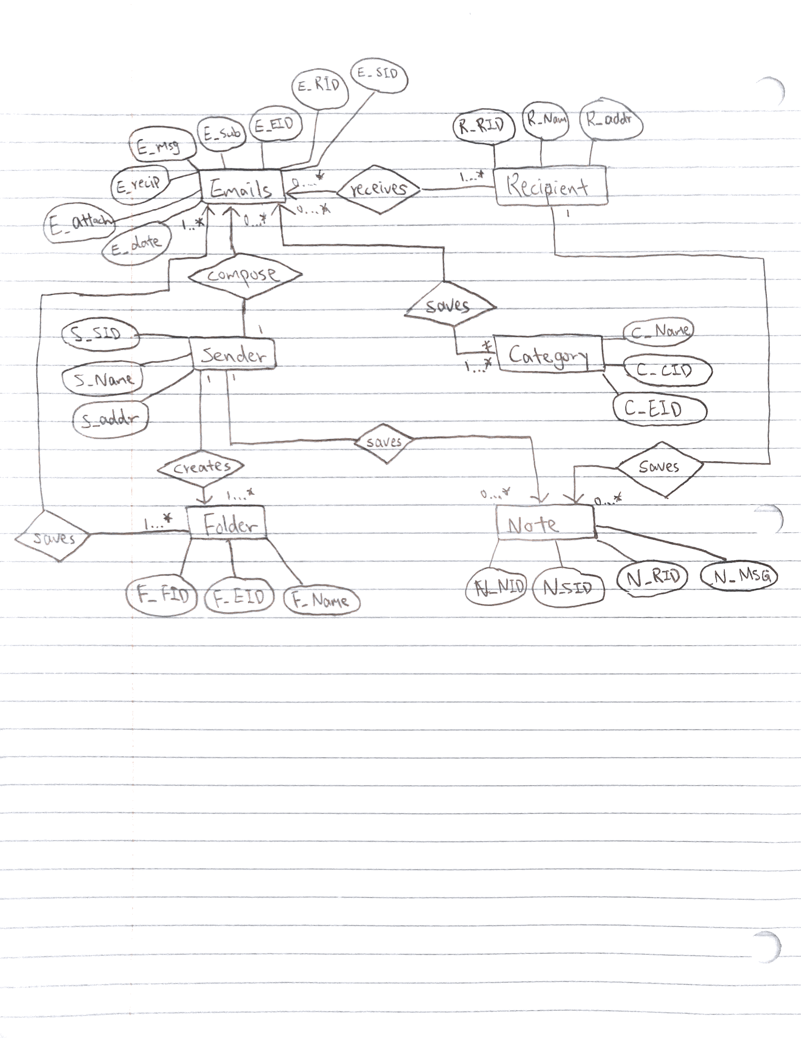Relation Schema**